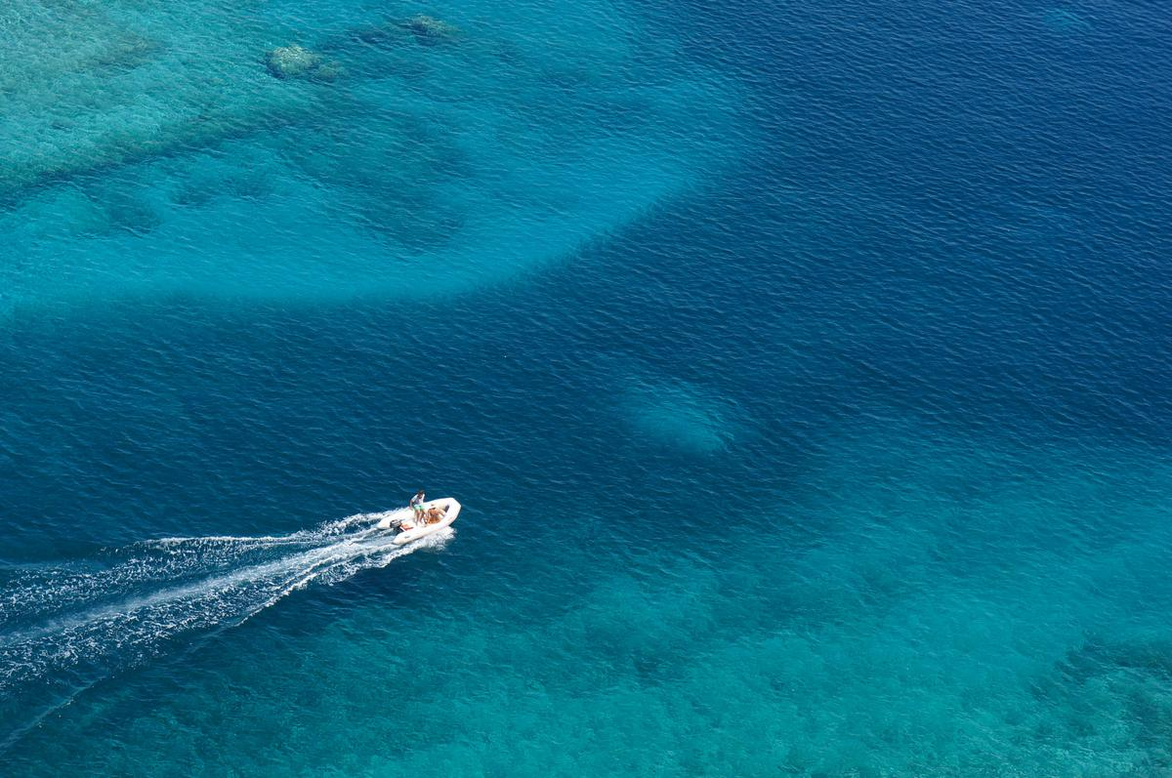

Marina Botafoch local 323 - 324 • 07800 IBIZA – BALEARES

Tel: +34 971 313926 • Fax: +34 971 313723

**www.coralyachting.com • coralyachting@coralyachting.com**

**MORE THAN 30 YEARS**

TAKING CARE OF YOU



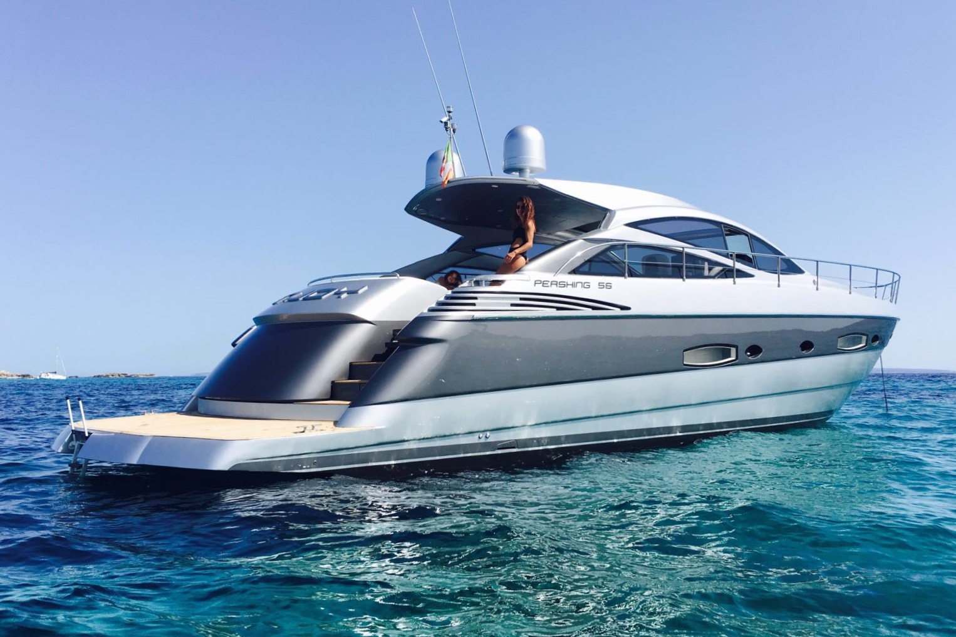

**MANGUSTA 72**

**SUNSEEKER PREDATOR 68**

**PERSHING 56**

**PERSHING 72**

**SUNSEEKER SUPERHAWK 34**

**SUNSEEKER CAMARGUE 50**

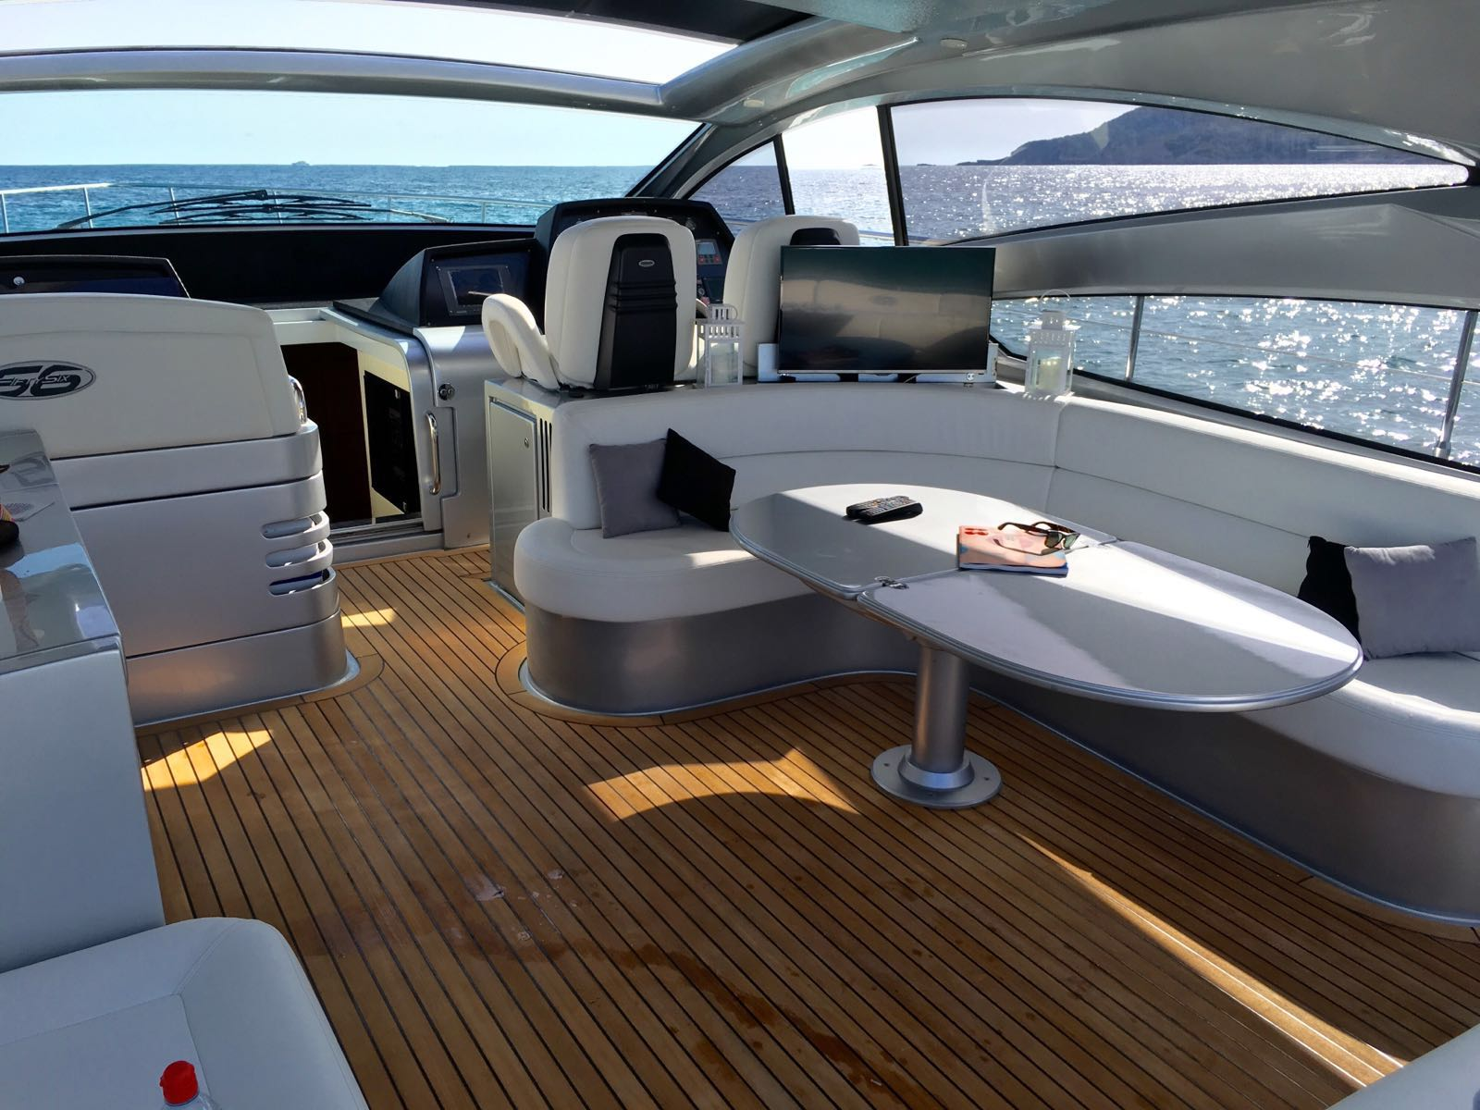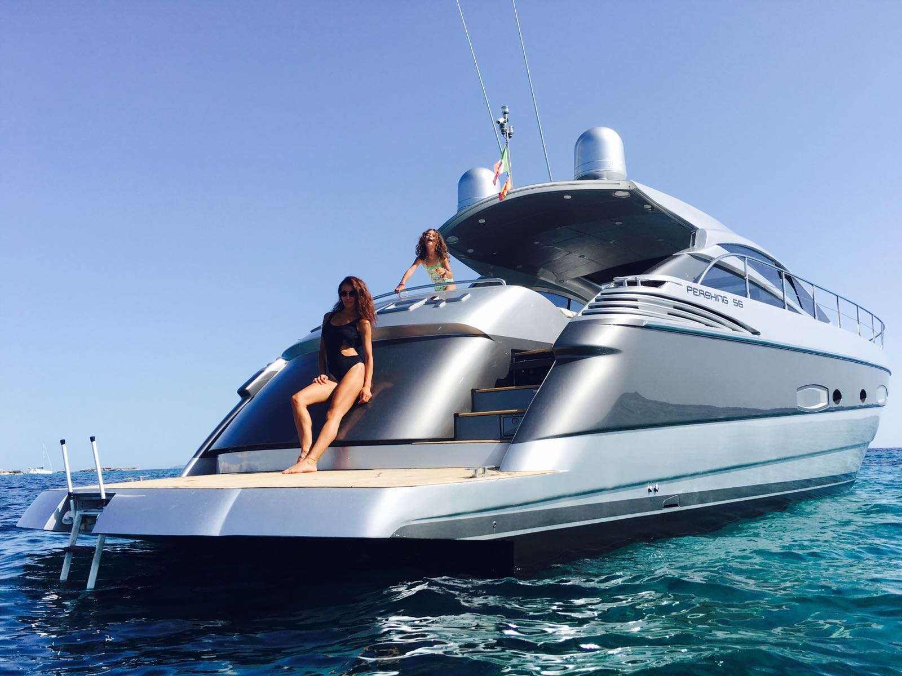

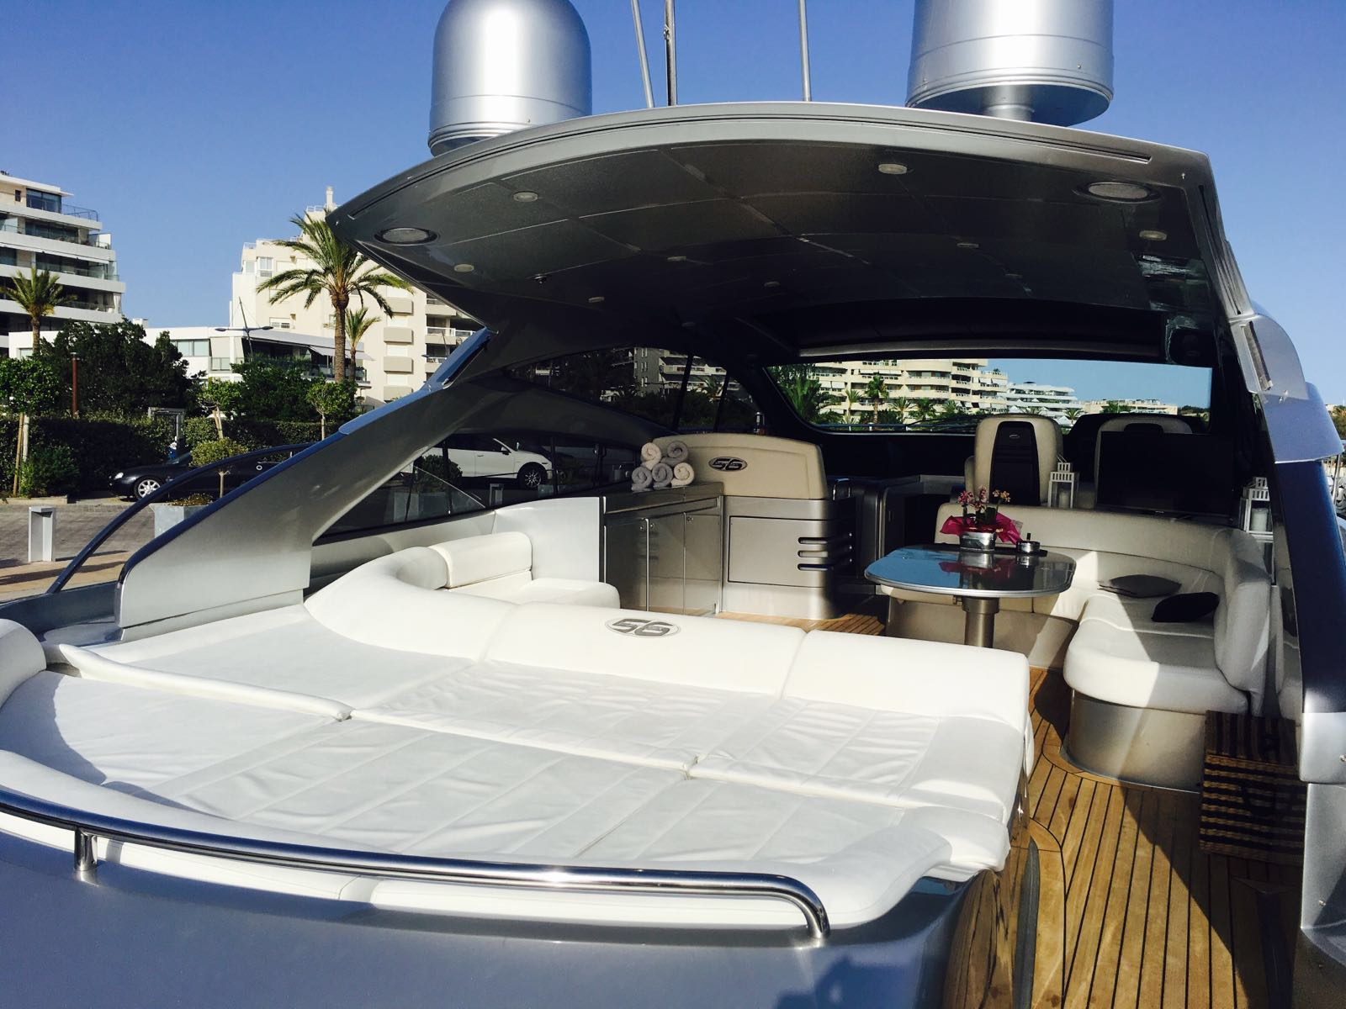

**PERSHING 56**

**Luxury, comfort and speed are main features of the Pershing 56. She includes TV/DVD/stereo/CD, generator, aircon, external shower, bathing platform and ladder, awning, refrigerator, GPS/plotter/radio VHF and tender boat. She can host 11 guest cruising and 6 guest sleeping in 3 cabins, 2 double and 1 twin with two single beds.**

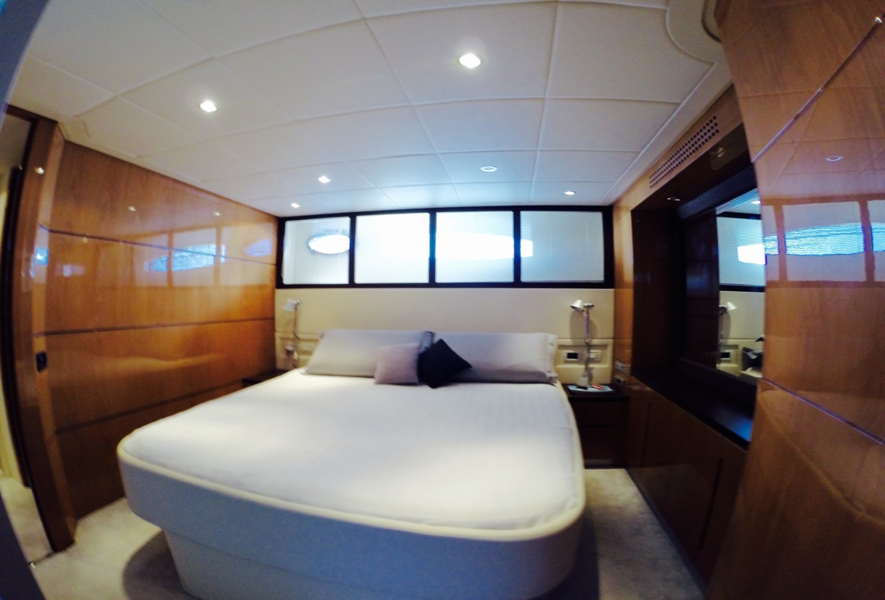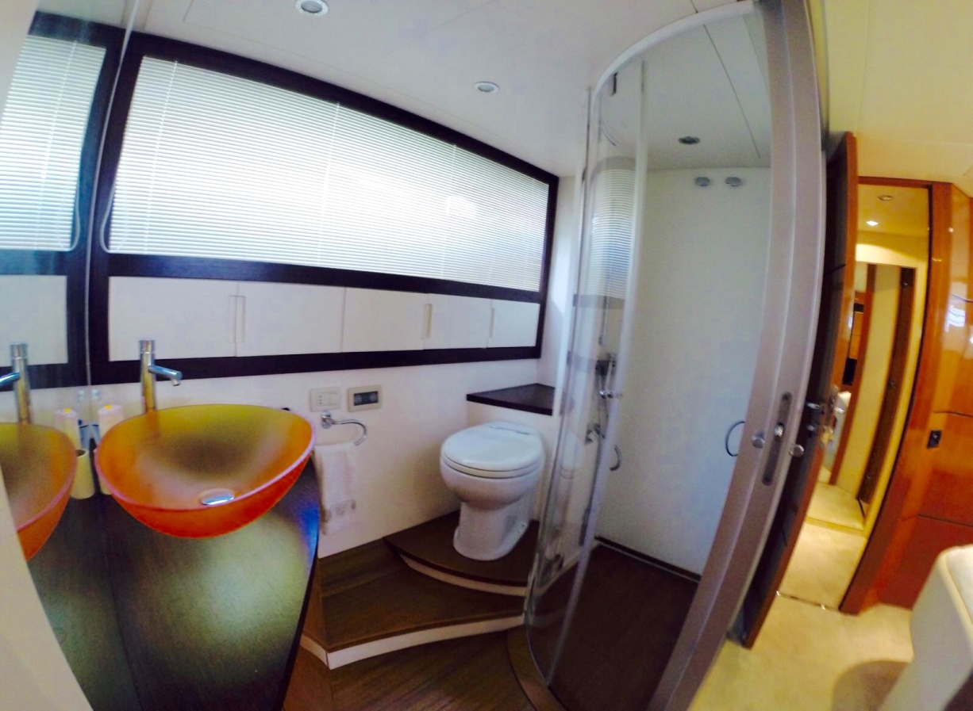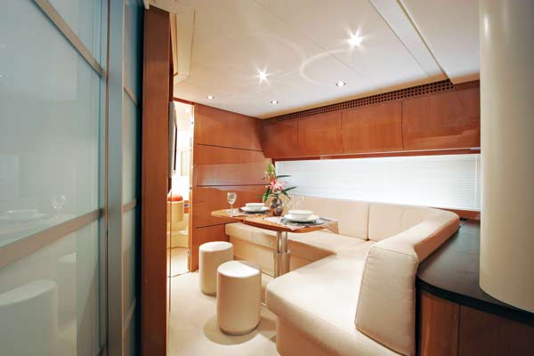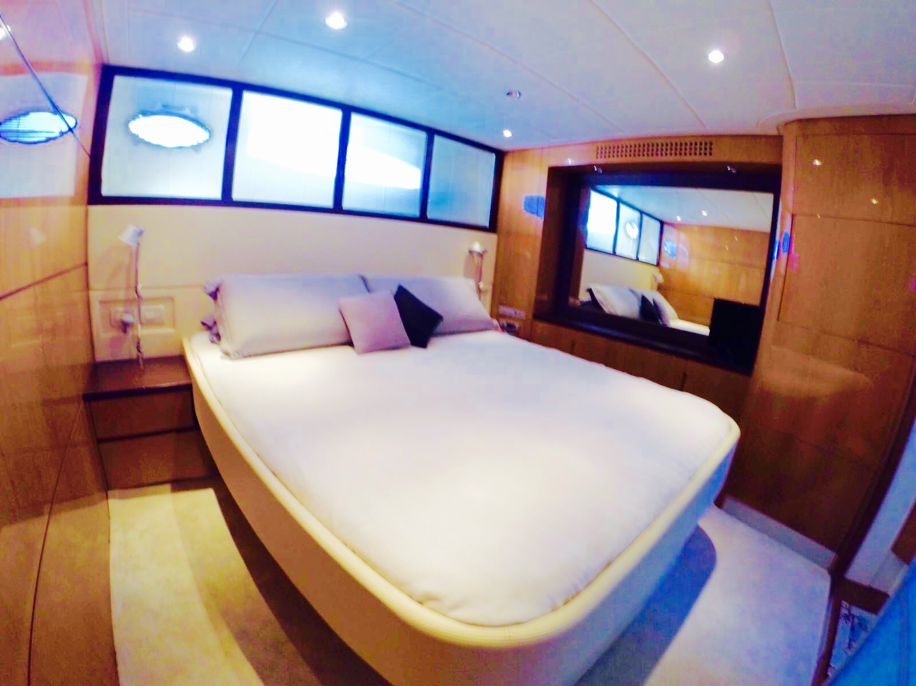

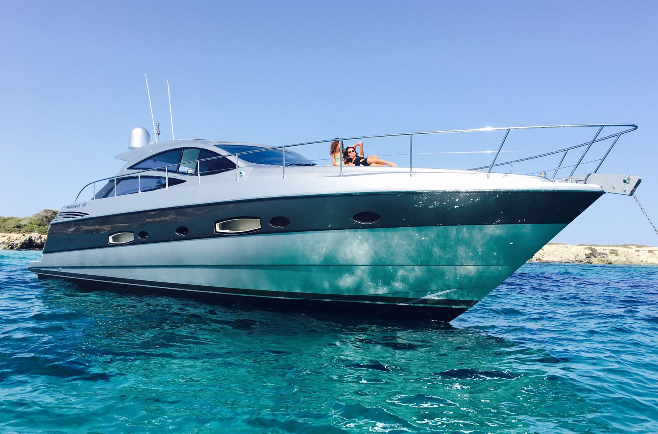

|  |
| --- |
| **PRICE PER DAY** |
| **€ 2.500 June - September** |
| **€ 3.200** **July – August** |
| **INCLUDED**  **Captain**  **Mooring at base port**  **Towels**  **Complimentary drinks**  **Ice**  **Snorkeling gear and donut**  **Tender**  **NOT INCLUDED** |
| **21% VAT**  **Fuel consumption** |

|  |
| --- |
| BUILDERS: **Pershing** |
| MODEL**: Pershing 56** |
| LENGTH**: 18 mtr** |
| BEAM**: 4,80 mtr** |
| ACCOMODATION**: 11 + Captain** |
| ACCOMODATION SLEEPING: **Max 6 (additional fee may apply)** |
| CABINS**: 3 (2 Double + 1 Twin)** |
| BATHROOM**: 3 (2 ensuite + 1)** |
| ENGINES**: 2 x V12 1360 Hp** |
| FUEL CONSUMPTION**: Aprox. 340 lts/h** |
| BASE PORT: **Marina Ibiza** |
| EXTRA TOYS:  **Seabob**   * **250€ (Low season)** * **350€ (High season)**   **Paddle Surf**   * **60€** |

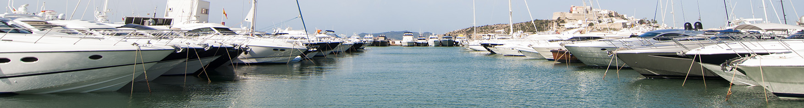

**PERSHING 56**